Simple Bank Account Management -J.Ragumaan

1. Project Overview
The Bank Account Management System is a full-stack web application developed using Spring Boot, MongoDB, and React.
It allows an admin user to securely manage bank accounts with proper authentication and business rule validation.
The application demonstrates real-world concepts such as authentication, CRUD operations, data validation, and frontend–backend integration.

2. Key Features
Authentication
- Admin login using Spring Security Basic Authentication
- Secure backend APIs
- Frontend login and logout functionality
- Session persistence using localStorage
Account Management
- Create bank accounts
- View all accounts
- Update account details
- Delete bank accounts
Business Rules
- Balance cannot be negative
- Balance cannot exceed maximum allowed limit
- Maximum limit cannot be less than current balance
Dashboard
- Displays total number of accounts
- Displays total balance in INR (₹)
- Quick action to create a new account
User Interface
- Responsive UI using Bootstrap
- Modal-based editing with blur background
- Admin navbar with logout option

3. Technology Stack
Backend
- Java 17
- Spring Boot
- Spring Security (Basic Authentication)
- Spring Data MongoDB
- MongoDB
- JUnit and Mockito for testing
- SLF4J for logging
Frontend
- React (Vite)
- React Router DOM
- Bootstrap 5
- Fetch API
- LocalStorage for authentication state

4. Project Structure
bank-account-management/
│
├── backend/
│ ├── controller
│ ├── service
│ ├── repository
│ ├── model
│ ├── security
│ └── tests
│
├── frontend/
│ ├── components
│ ├── services
│ ├── utils
│ └── App.jsx
│
└── README.md

5. Admin Credentials
Username: admin
Password: admin123

6. Backend Setup
- Ensure MongoDB is running on localhost:27017
- Configure application.properties:
spring.data.mongodb.database=bankdb
spring.data.mongodb.host=localhost
spring.data.mongodb.port=27017
- Run the backend:
mvn spring-boot:run
Backend will run on:
http://localhost:8080

7. Frontend Setup
- Navigate to frontend folder:
cd frontend
- Install dependencies:
npm install
- Run the application:
npm run dev
Frontend will run on:
http://localhost:5173

8. API Endpoints
Method | Endpoint | Description
GET | /accounts | Fetch all bank accounts
POST | /accounts | Create new account
PUT | /accounts/{id} | Update account details
DELETE | /accounts/{id} | Delete account
All endpoints are protected using Basic Authentication.

9. Login & Logout Flow
Login
- Admin enters credentials
- Backend validates using Spring Security
- Credentials stored in localStorage
- Redirects to dashboard automatically
Logout
- Clears authentication data from localStorage
- Redirects to login page
- Protected routes become inaccessible

10. Testing
- Service-level unit tests using JUnit
- Validation tests for:
  - Negative balance
  - Max limit enforcement
  - Account update rules
Run tests:
mvn test

11. Learning Outcomes
- Implementing secure authentication
- Enforcing business rules at service layer
- Building RESTful APIs using Spring Boot
- Integrating React frontend with secured backend
- Managing authentication state on frontend
- Debugging real-world full-stack issues

12. Future Enhancements
- JWT-based authentication
- Role-based access control
- Transaction history
- Pagination and search
- Docker deployment
- Cloud hosting

13.Screenshot
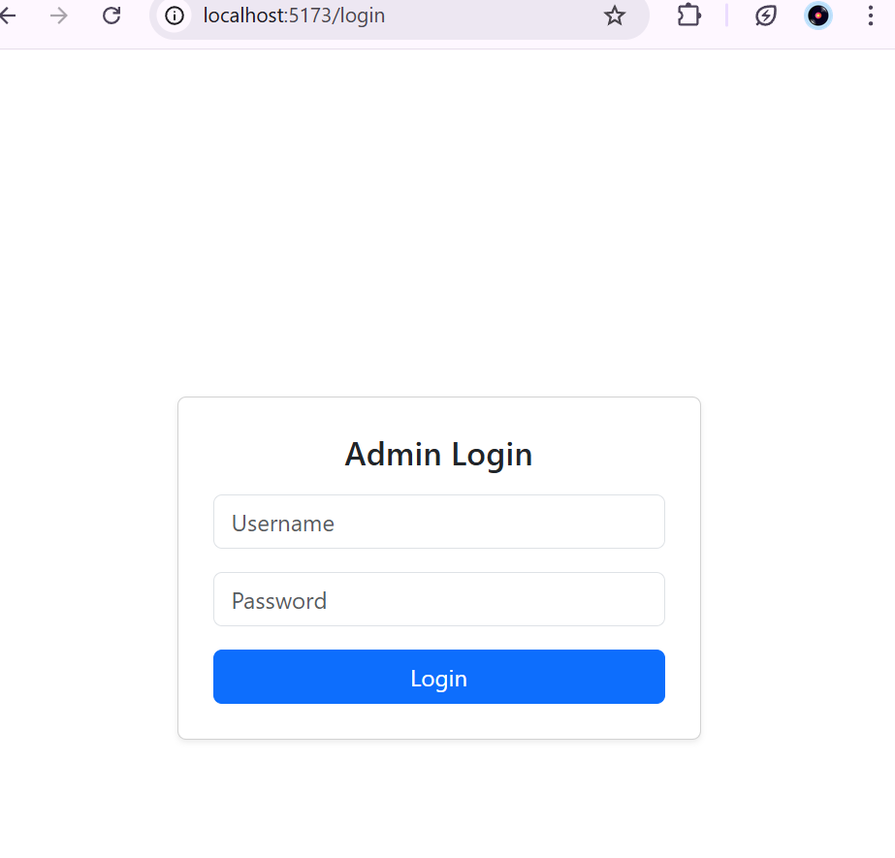
1.AdminLogin

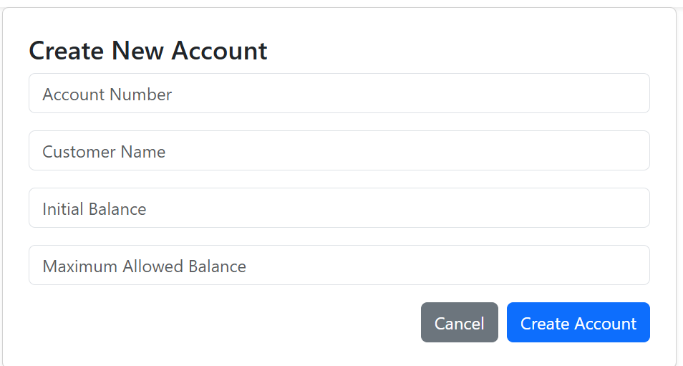
2.Form Creation

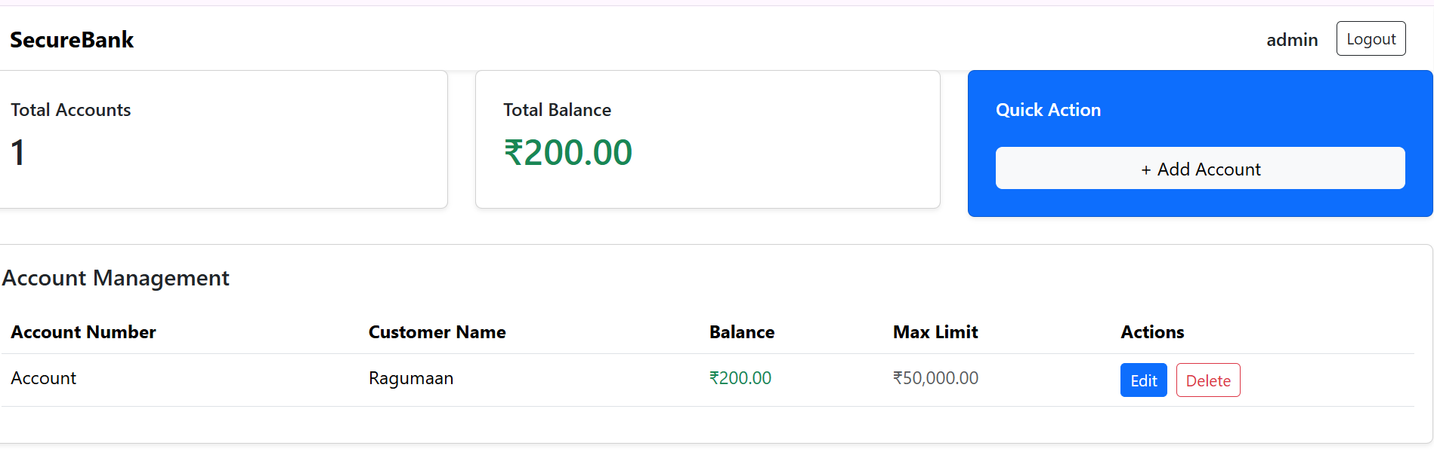
3.Dashboard

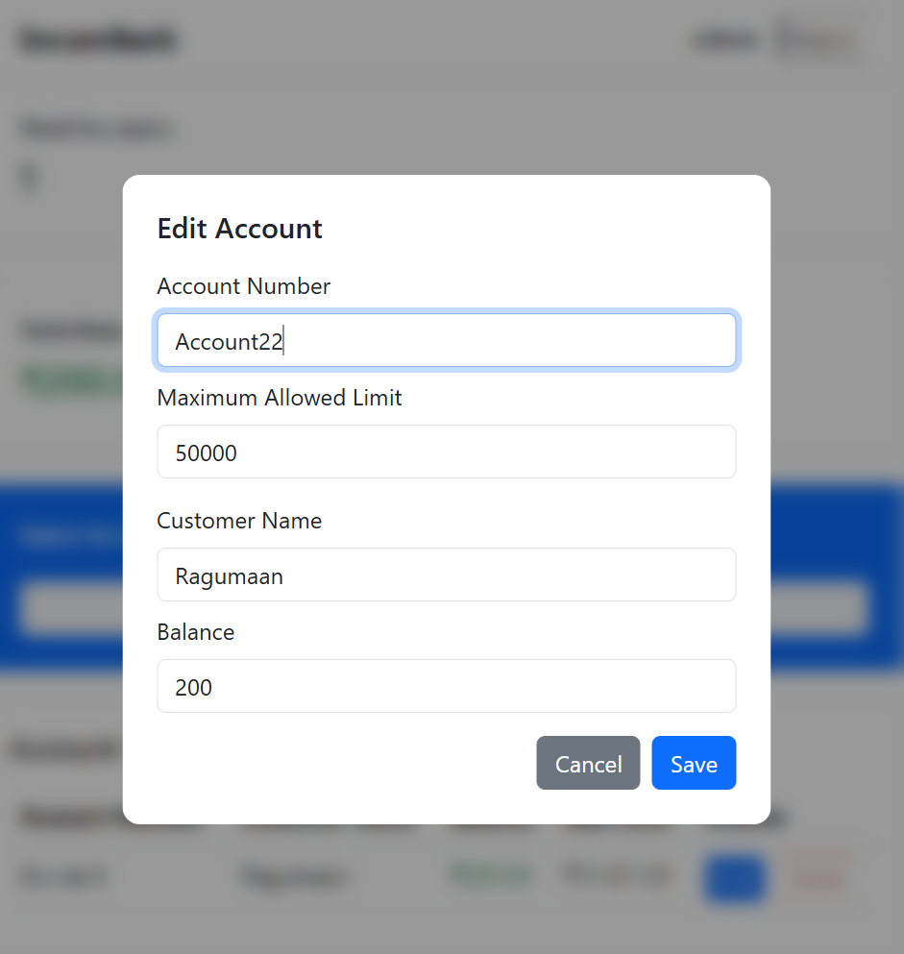
4.Edit Account

14. Conclusion
This project demonstrates a complete full-stack banking application with secure authentication, proper validation, and a clean user interface.
It follows industry best practices and serves as a strong foundation for enterprise-level applications.

